[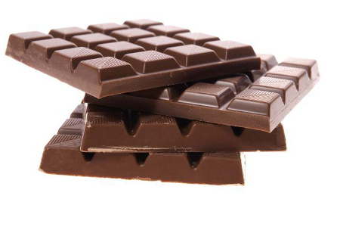](http://www.google.hr/url?sa=i&rct=j&q=&esrc=s&source=images&cd=&cad=rja&uact=8&ved=0ahUKEwiCzKG6rtbJAhUDvRQKHefUBOwQjRwIBw&url=http://www.piercepioneer.com/study-shows-that-chocolate-might-actually-be-good-for-you/42006&bvm=bv.109910813,d.d24&psig=AFQjCNEv8mbSik-725ohgY9-CBFxISDn1A&ust=1450011067990432)[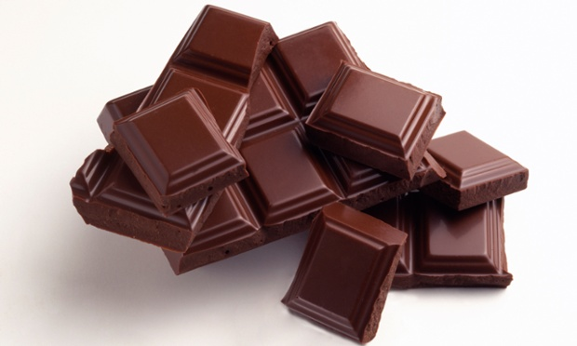](http://www.google.hr/url?sa=i&rct=j&q=&esrc=s&source=images&cd=&cad=rja&uact=8&ved=0ahUKEwjF84Onm9bJAhUE6RQKHfk8AXYQjRwIBw&url=http://weknowyourdreams.com/chocolate.html&bvm=bv.109910813,d.d24&psig=AFQjCNHUWiFXb-tqyifrCdhquNvuM11YYw&ust=1450005935397003)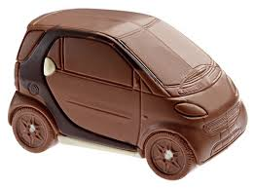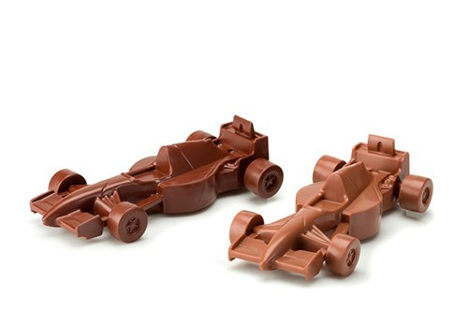

250g

Cijena:15,99 kn

100g

Cijena:8,99 kn

„Đuka“ mliječna čokolada

Naši proizvodi :

„Čoko F1“

„Čoko Smart“

Čokolada u oblicima

48g

Cijena:5,50 kn

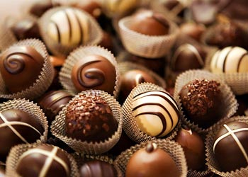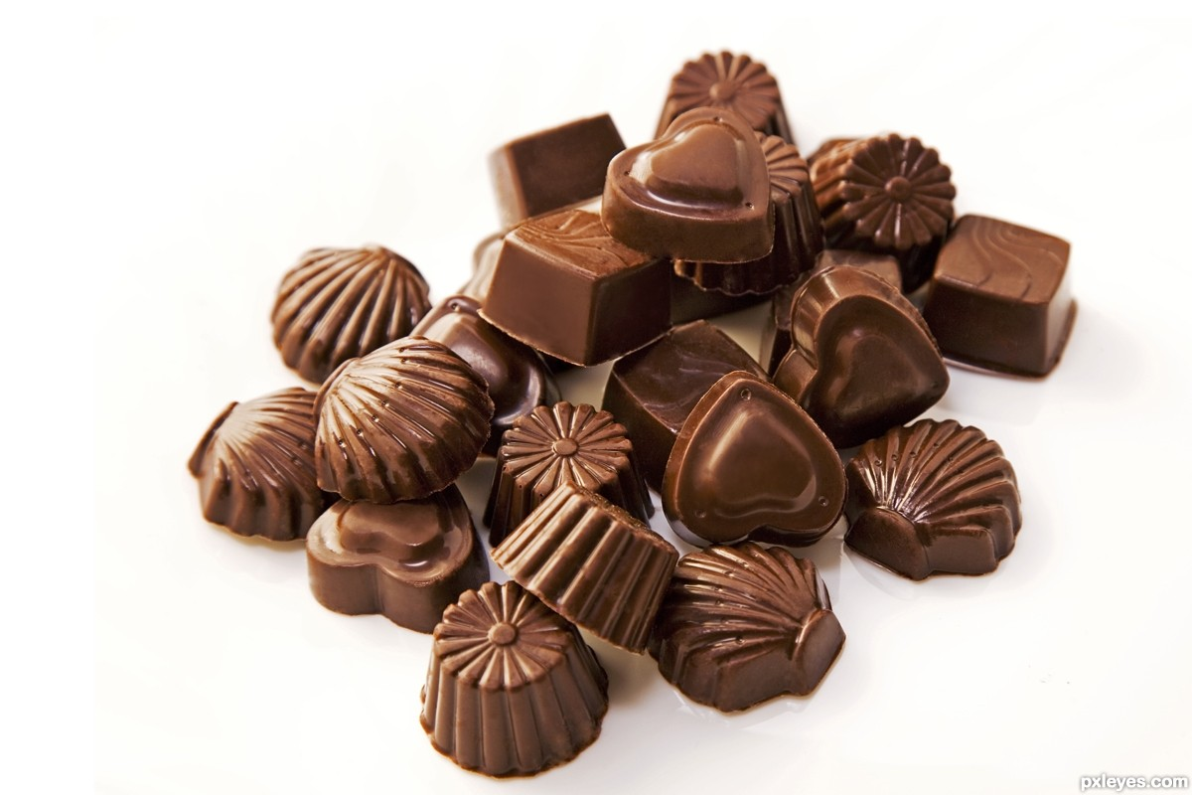

125g

Cijena:15,80 kn

300g

Cijena:51,65 kn

bombonjera “Co”  
 -tamna čokolada

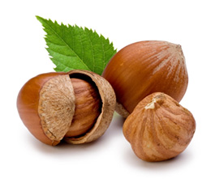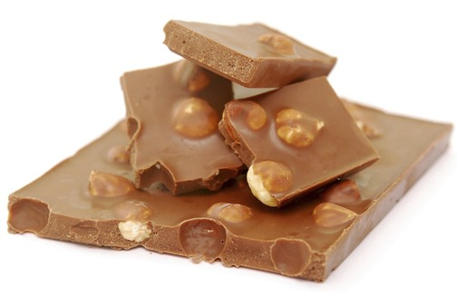

Čokolada “MB7” s okusom lješnjaka

100g

Cijena:9,50 kn

250g

Cijena:16,99 kn

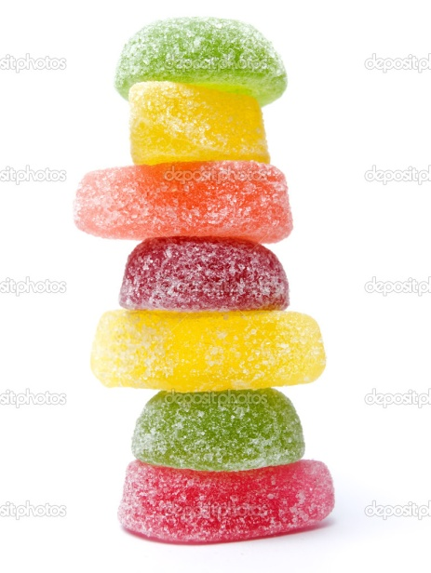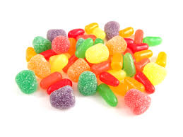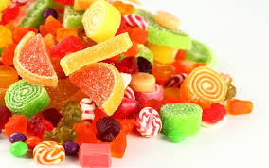

100g

cijena:7,99 kn

„Juki“gumeni bomboni

[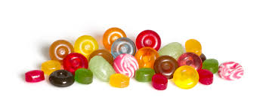](http://www.google.hr/url?sa=i&rct=j&q=&esrc=s&source=images&cd=&cad=rja&uact=8&ved=0ahUKEwiB5fmWqdLJAhWELhoKHR2XACcQjRwIBw&url=http://www.gumlinkcc.com/products/candy/pages/hardboiledcandy.aspx&psig=AFQjCNEwSAb1UKThdz8K8nknDucV_5-0-Q&ust=14)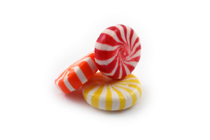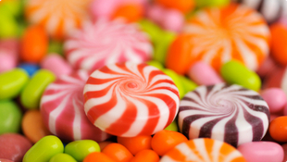

“Frki”tvrdi bomboni

100g

cijena:6,70 kn

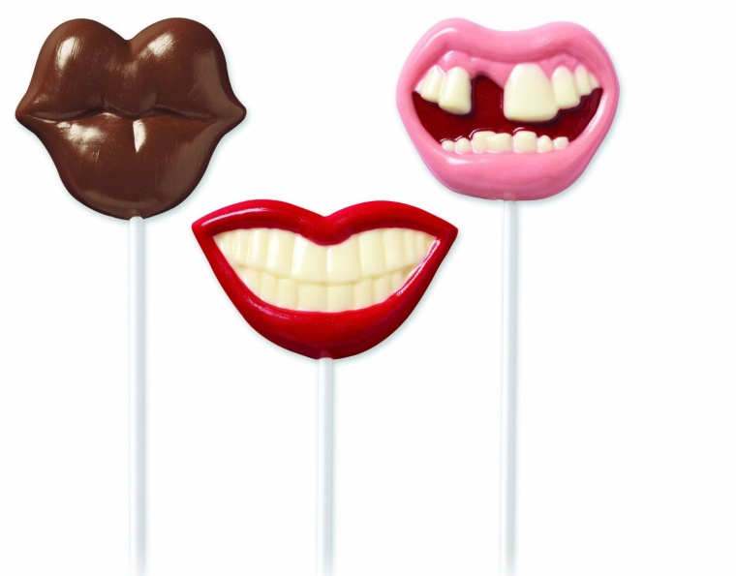[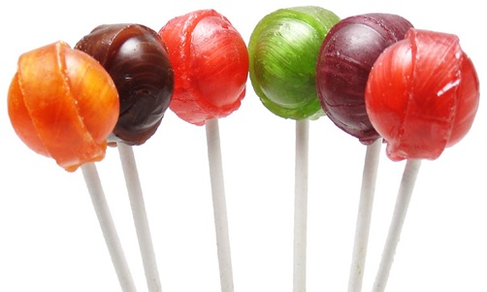](http://www.google.hr/url?sa=i&rct=j&q=&esrc=s&source=images&cd=&cad=rja&uact=8&ved=0ahUKEwjzqvjkq9bJAhUIcRQKHfrwCPYQjRwIBw&url=http://urir.livejournal.com/89001.html&bvm=bv.109910813,d.d24&psig=AFQjCNE3S922KOPkcSCbY-jUUMe5Vp1JVA&ust=1450010167279610)[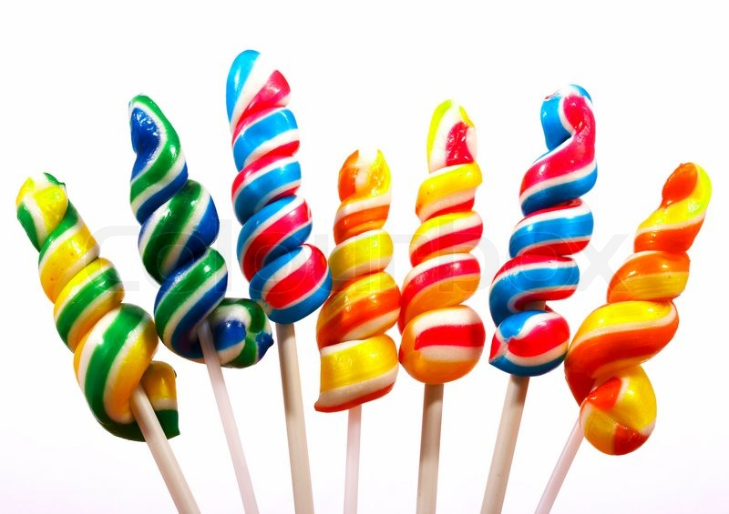](https://www.google.hr/url?sa=i&rct=j&q=&esrc=s&source=images&cd=&cad=rja&uact=8&ved=0ahUKEwiviaTqxtbJAhXLWxQKHX5dAqcQjRwIBw&url=https://www.colourbox.com/image/sticks-of-twisted-candy-as-a-treat-for-the-kids-image-2249373&psig=AFQjCNF-z9U14_BtOzQcmgDbkiOR4swLZA&ust=1450013461664795)[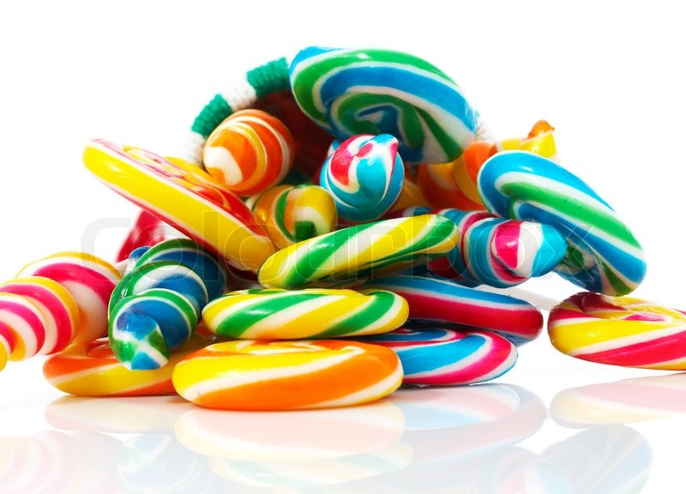](https://www.google.hr/url?sa=i&rct=j&q=&esrc=s&source=images&cd=&cad=rja&uact=8&ved=0ahUKEwiviaTqxtbJAhXLWxQKHX5dAqcQjRwIBw&url=https://www.colourbox.com/image/colored-twisted-candy-as-a-christmas-treat-image-2249566&psig=AFQjCNF-z9U14_BtOzQcmgDbkiOR4swLZA&ust=1450013461664795)

Lizalice “Dudlaća” raznih okusa i oblika

Cijena:1,50 kn/kom

Žvake raznih okusa

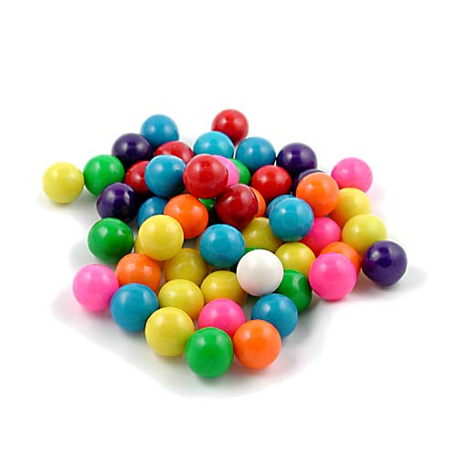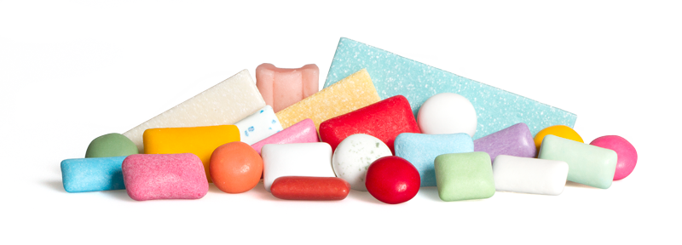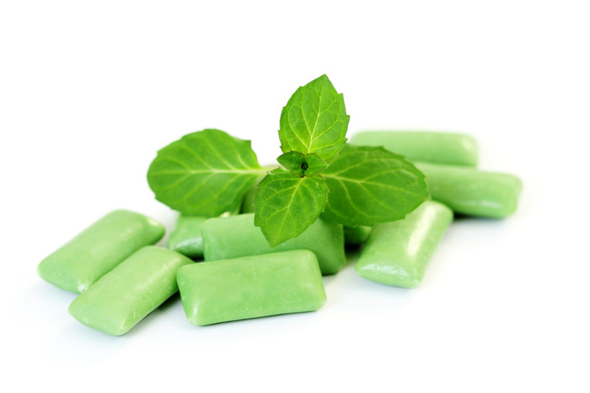

Cijena:0,99 kn/kom